编号：

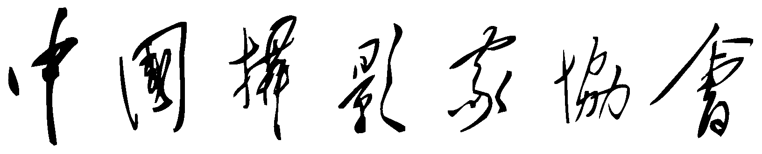

入 会 申 请 书



姓　名：

|  |  |  |  |  |  |  |  |  |  |  |  |  |  |  |  |  |  |  |  |  |  |  |  |  |  |  |  |  |  |  |  |  |  |  |  |  |  |  |  |  |
| --- | --- | --- | --- | --- | --- | --- | --- | --- | --- | --- | --- | --- | --- | --- | --- | --- | --- | --- | --- | --- | --- | --- | --- | --- | --- | --- | --- | --- | --- | --- | --- | --- | --- | --- | --- | --- | --- | --- | --- | --- |
| **姓　　名** |  | | | | | | | **笔名** | | | |  | | | | | | **性　　别** | | | | | |  | | | | | | | | | | 照  片 | | | | | | |
| **出生日期** |  | | | | | | | **民族** | | | |  | | | | | | **是否职业摄影（注）** | | | | | | **是** | | | **否** | | | | | | |
| **政治面貌** |  | | | | | | | **学历** | | | |  | | | | | | **摄影特长**  **（勾选1项）** | | | | | | **记**  **录** | | **艺术** | | | | **商业** | | | |
| **工作单位** |  | | | | | | | | | | | | | | | | | **理**  **论** | | **编辑** | | | | **图书** | | | |
| **职务** |  | | | | | | | **职称** | | | |  | | | | | | **教育** | | **组织工作** | | | | | | | |
| **通信地址** |  | | | | | | | | | | | | | | | | | | | | | | | **邮政编码** | | | | | | |  | | | | | | | | | |
| **固定电话** | | | | | | |  | | | | | | | | | |
| **身份证号** |  |  | |  |  |  |  | |  |  |  | |  |  |  |  |  | |  |  |  |  | **手机**  **号码** | |  | | |  |  | | |  |  | |  |  |  |  |  |  |
| **主**  **要**  **经**  **历** |  | | | | | | | | | | | | | | | | | | | | | | | | | | | | | | | | | | | | | | | |
|  | | | | | | | | | | | | | | | | | | | | | | | | | | | | | | | | | | | | | | | |
|  | | | | | | | | | | | | | | | | | | | | | | | | | | | | | | | | | | | | | | | |
|  | | | | | | | | | | | | | | | | | | | | | | | | | | | | | | | | | | | | | | | |
|  | | | | | | | | | | | | | | | | | | | | | | | | | | | | | | | | | | | | | | | |
|  | | | | | | | | | | | | | | | | | | | | | | | | | | | | | | | | | | | | | | | |
|  | | | | | | | | | | | | | | | | | | | | | | | | | | | | | | | | | | | | | | | |
| **作**  **品**  **获**  **奖**  **及**  **发**  **表**  **证**  **明**  **目**  **录** | 1 | |  | | | | | | | | | | | | | | | | | | | | | | | | | | | | | | | | | | | | | |
| 2 | |  | | | | | | | | | | | | | | | | | | | | | | | | | | | | | | | | | | | | | |
| 3 | |  | | | | | | | | | | | | | | | | | | | | | | | | | | | | | | | | | | | | | |
| 4 | |  | | | | | | | | | | | | | | | | | | | | | | | | | | | | | | | | | | | | | |
| 5 | |  | | | | | | | | | | | | | | | | | | | | | | | | | | | | | | | | | | | | | |
| 6 | |  | | | | | | | | | | | | | | | | | | | | | | | | | | | | | | | | | | | | | |
| 7 | |  | | | | | | | | | | | | | | | | | | | | | | | | | | | | | | | | | | | | | |
| 8 | |  | | | | | | | | | | | | | | | | | | | | | | | | | | | | | | | | | | | | | |

注：职业摄影：指以摄影为职业（或主要谋生手段）的人员。如摄影记者、摄影教师、职业摄影师、企事业单位摄影干事、图片编辑、摄影图书出版人、摄影组织工作者、自由摄影师和其他专职摄影从业者等。

|  |  |  |  |  |
| --- | --- | --- | --- | --- |
| **申**  **请**  **作**  **品** | **标　　题** | **创作时间** | **发表或获奖情况** | |
|  |  |  | |
|  |  |  | |
|  |  |  | |
|  |  |  | |
|  |  |  | |
|  |  |  | |
|  |  |  | |
|  |  |  | |
| **申请人签名或盖章** | （填表时间）　　　　年　　月　　日 | | | |
| **介**  **绍**  **人**  **意**    **见** | 介绍人：（签名） 会员证号： | | | |
| 介绍人：（签名） 会员证号： | | | |
| **团体会员**  **或本单位**  **推荐意见** | （盖章） | | | |
| **秘 书 长**  **办公会议**  **审批意见** | 批准日期　　　　年　　月　　日 | | | |
| **摄影经历**（包括摄影创作、摄影论文、摄影专著和其它与摄影有关的工作，并请注明创作时间、地点和作品出版、发表处） | | | |
|  | | | |
| **授权声明：**  　　本人授权中国摄影家协会信息中心负责管理的中国摄影家协会图片库为非独家代理机构，代理销售本人申请加入中国摄影家协会时提交的全部作品的使用权。  【同意或不同意授权均不影响申请人加入中国摄影家协会。中国摄影家协会信息中心承诺，一般情况下，作者收入为所代理图片实际收入（即扣除国家规定的营业税费后）的 50%（注：双方在分成方面有特殊约定的情况除外）。  请在以下相应“□”内划“√”并签字。如同意授权。】  **同意授权** □　　**不同意授权** □    授权人签字或盖章： | | | |